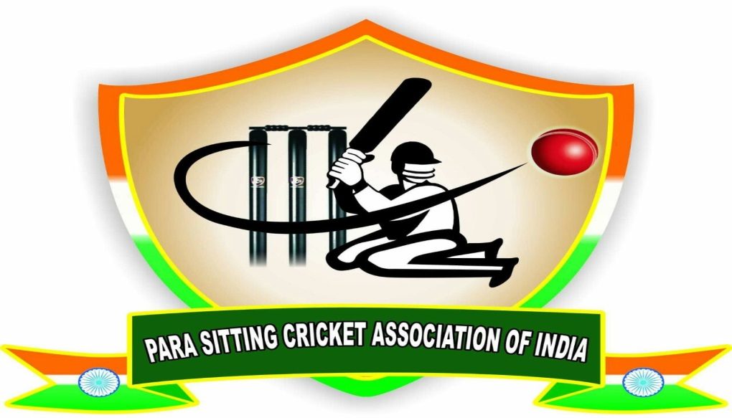

PARA SITTING CRICKET ASSOCIATION OF INDIA

PARA SITTING CRICKET RULES

Rules Compiled By

Dr. S.F Mohammad Gaddaffe

PARA SITTING CRICKET RULES

Law 1: The Game

- A match consists of 2 innings, one per team, each of 20 overs. One player allowed to bowl maximum 4 overs where a bowler is unable to complete an over due to an injury or illness, any bowler who had not completed 4 overs can bowl remaining balls.
- A match will be won by the side which, at the end of both innings, has the highest Team Score.
- In the event of the Team Scores being equal, the winner shall be decided by super over. One over shall be given to each side.
- Only one bowler can bowl unless bowler injures. In case of injury one more bowler can be used.
- Only 2 wickets are allowed for batting side. Maximum 3 batsmen allowed to bat.
- Players who are all going to bat and bowl in the super over must be informed to the organization committee before super over game starts.
- Even after super over Team Scores are equal, the winner shall be:
  - The team that lost the least number of wickets.
  - The team that scored the most 6’s.
  - The team that scored the most 4’s.
  - The team that conceded the fewest extras.
  - If both teams are still equal, then the winner will be decided by the toss of a coin.
- Ball to be used shall be decided by organization committee either hard tennis ball or rubber ball.
- Number of overs for particular match shall be decided by tournament committee.
- Three new balls per innings shall be used. Replace with old ball only if damaged or ball lost.

Law 2: Control of Play

- Before the match, two umpires shall be appointed to control the game with absolute impartiality, as required by the laws.
- No umpire shall be changed during the match. The umpire shall be the sole judge of fair and unfair play.
- In all disputes, the ruling umpire’s decision is final.

Law 3 : Playing Area Layout and Dimensions

a. The wicket is the area between the bowling, batting and return creases.
b. The stumps shall be of equal and sufficient size to prevent the ball passing through them. Their tops shall be 71.1 cm above the ground.
c. The bails shall be 11.1 cm in length and when in position shall not extend more than 1.3 cm beyond the stump.
d. Two sets of wickets, each 22.86 cm wide, and consisting of three stumps with two bails on the top, shall be pitched opposite to each other, 16.45 m / 18 yd. apart to 18.28 m / 20yd apart to.
e. The wicket line shall be marked in line with the stumps at each end, and shall be 1.83 m in width, with the stumps in the Centre, and the Centre stumps 16.45 m / 18 yd. apart to 18.28 m / 20yd.
f. The popping crease, which is the back edge of the of the crease marking, shall be in front of, and parallel with, the wicket lines at both ends. It shall have its back edge 1.22 meters from the Centre of the stumps. At the batter’s end it shall extend from one side of the wicket to the other and shall be called the batting crease. At the bowler’s end it shall be the same length as the wicket line and it shall be called the bowler’s crease or front hand line.
g. The return crease at both ends shall be at right angles to the wicket line and shall extend from the wicket line to the popping crease. Where a return crease marking is used, it shall be the inside edge of that marking. Where a clearly contrasting pitch color is used, it may be the edge of the pitch.
h. Four circle lines will be drawn. First line or 1 run line will be 24 yard circle. Second line or 2 run line, Third line or 3 run line and boundary line will be drawn based on the size of the total ground. But, circular line should be atleast 5 metre longer than inner circular line.
h. All players must abide by the rules and regulations.

GROUND MAP:

Min 5m

Min 5m

Min 5m

16.45m to 18.28m

1 Run line

2 Run line

3 Run line

Boundary line

Law 4: Players

- Matches are played between two teams of 11 players.
- 11 Players shall be pick to play based on below categorization
- UW : 3 - 6 Players
- CWCACR : 3 – 5 Players
- CWCR : 0 – 3 Players
- CWCA : 0 – 2 Players
- SL : 0 – 2 Players
- OL or NL or WHS : 0 – 1 player
- Players categorization (Note: All the below categorization is for leg affected and lost players ):
- UW : Unable to walk
- CWCACR : Can walk with Caliber and Crutches
- CWCR : Can walk with Crutches
- CWCA : Can walk with Caliber
- SL : Short leg
- OL or NL or WHS : One leg or No Leg or Can walk with help of hand support
- If no players available in the categories CWCR OR CWCA OR SL OR OL or NL or WHS, players in the other category can play but it should not cross the category maximum limit ( i.e if no player available in the category SL, then 2 players in the category CWCA shall play. But it should not be more than 2 ).
- It is mandatory to include 6 players in the playing XI from the categories UW and CWCACR.

Law 5: Substitute Players

- Substitutes shall be allowed in the event of injury or illness during play.
- Substitutes shall be allowed only to field in the place of the person they replace.
- 4 players shall be reserved as substitute based on above categorization and maximum limit. It is must to take 1 player each from the categories UW and CWCACR as subsitute.
- Players in the same categorization or player in the less category shall be selected as substitute on availability (i.e. If player in the CWCACR category injured then player in the same category CWCACR (1st preference) or player in the UW below category (2nd preference)).
- When substitute player in the same category or less is not available then only above category player shall replace (i.e. If player in the CWCACR injured then player in the CWCL shall replace on unavailability of substitute player in the CWCACR and UW).
- Only 2 players allowed as substitute at the same time.

Law 6: Batting

- Batter shall be allowed to play perfectly in sitting position.
- Batter shall allow to sit on his legs.
- Batter shall not allowed to use the power of legs while batting.
- Two batsmen shall play by rotating the strike.
- Strike Rotation
- If Batter scores 1 or 3 runs then other batsman shall strike the next ball if over not ends.
- No Strike rotation if batsman scores 2, 4, 6 or no runs unless over ends.
- If Batter scores 1 or 3 Runs in the last legal ball of the over then same batsman should strike next over’s first ball. If Batsman scores 2, 4, 6 or No runs, other batsman shall be striking the next over’s first ball.
- Both the batsmen shall play in one end of the pitch.
- During one batsman strikes the ball, non-striker shall be allowed to sit in the leg side/onside of the striker with minimum of 3m distance.
- If batter uses his power of legs while hitting the ball umpire shall give warning for the first time. If batter repeats the same during same match batsman shall ban for that particular match.
- Bat to be used by the batsman should satisfy ICC cricket rules.

Law 7: Scoring

Runs may be scored as follows:

- Every time batter hit the ball with the bat and the ball shall crosses 1 run line, 1 run is scored
- Fielders any part of the body touches 1 run line while stopping the ball hit by batter, 1 run is scored
- Every time batter hit the ball with the bat and the ball shall crosses 2 run line, 2 runs scored
- Fielders any part of the body touches 2 run line while stopping the ball hit by batter, 2 runs is scored
- Every time batter hit the ball with the bat and the ball shall crosses 3 run line, 3 runs scored
- Fielders any part of the body touches 3 run line while stopping the ball hit by batter, 3 runs is scored
- When the ball reaches or is hit over the agreed boundaries, 4 and 6 runs respectively are scored.
- Overthrows are not counted as runs.
- One bonus run is scored for a no-ball (Crease, without pitching the ball, using legs power) or wide.
- A no-ball is an additional 1 run, plus the number of runs scored off that no-ball, to the batting side.
- No runs shall be provided for single bounce no ball.
- Two consecutive bounce no balls shall ends in 1 run for batting side.
- if batsman uses his legs(stands) power to hit the ball no runs shall be awarded.
- If batsman scores in balls like bowler bowls ball height without pitching, bowler uses his power of legs(Stands) and crease no ball along with runs scored by batsman 1 run shall be added to the total.

Law 8: Bowling

- Bowler shall be allowed to bowl perfectly in sitting position or atleast on hand should touch the ground while delivers the ball.
- Bowler shall not allow to use the power of legs while bowling.
- All bowling must be with an overarm action.
- If bowler to fail to follow any of Law 8) a, b, c umpire shall give warning for the first time. If bowler repeats the same during same match bowler shall ban from bowling remaining balls and overs for that particular match.
- Bowler allow to sit on his legs

Law 9: No-Balls

- A no-ball occurs when –
  - a ball is being bowled and the arm straightens or bends during the delivery. If the arm is bent all the way through the delivery, it is a legal delivery. The umpire must be completely satisfied with the absolute fairness of a delivery.
  - at the point of delivery, the hand or any part of the body is outside the bowling / return crease.
  - the ball bounces not only more than stumps and also not reachable by batter. bouncer shall be decided by umpire
  - at the point of delivery, there are more than two fielders behind the batter on the leg side. On the line is considered in the offending half.
  - a fielder or part of a fielder is on the pitch prior to the ball being played at or played by the batter
  - the bowler changes their style or sitting direction without informing the umpire, e.g. round the wicket delivery, to over the wicket delivery. The umpire must make the batter aware of any such changes.
  - the wicketkeeper takes the ball in front of the stumps, the ball not having touched the batter or their bat.
  - the wicketkeeper cannot have the gloves in front of the line of the stumps as the ball is delivered.
  - Bowler bowls above the stumps without pitching the ball and not hit by batter
  - Bowler uses his leg power or stands while bowling.
- Batters shall be dismissed off a no-ball only by interference.

Law 10: Field Placement

- There shall be no more than two fielders behind the batter on the leg side [on side]
- Fielders close to the wicket may not move in such a manner as to disturb the batter, until the batter has played the ball.
- The ball is considered bowled once it has left the bowler’s hand, and moved forward of the bowling crease.
- There shall be no fielder, or part of a fielder, other than the bowler on, or extending over the pitch until the ball has been played at or played by the bowler.
- All fields should be sitting position or both the hands should touch the ground before bowler bowls.
- If a, b, c, d is contravened , the umpires shall call “no-ball.”

Law 11 : Wides

- A wide shall be called if, as the ball crosses the batting crease, it is not touched by the batter’s bat or person and in relation to painted lines either side of the wickets –
  - It passes on the batter’s off side and is on or wide of the off side line as marked on the pitch,
  - It passes on the batter’s leg side and is on or outside of the leg side line as marked on the pitch. Note – the ball must clearly pass down the leg side of the batter; and any ball passing between any part of a batter and the wicket is not wide.
b. A wide - does not count as part of an over, and 1 run shall be added to the batting score.
c. A batter may be dismissed off a wide ball only by way of - hit wicket, run-out, stumped, handled ball or obstruction on the field.

Law 12: Appeals for Dismissals

a. The umpire shall not give the batter out unless appealed to by the opposing team. Such an appeal must be made immediately.
b. An appeal shall cover all forms of dismissals.
c. An appeal must be made in the form of a verbal question to the umpire.
d. The umpire’s decision is final. The umpire may alter a decision, provided such alteration is done promptly.

Law 13: Striking the Wicket in Dismissal

a. The batter is “out” if the ball, the batter or the batter’s bat, removes one or both bails from the stumps. A disturbance of a bail does not constitute a dismissal.
b. The batter is out if a fielder dislodges one or both bails from the top of the stumps with a throw, or with the ball held in one or both hands.
c. For a batter to be given “out” - the stumps must be upright before being struck. The stumps when standing are always alive, irrespective of one or two bails being removed. If the bail has been removed during play, the stumps may be hit again and the batter given out.

Law 14: Dismissals

a. Only one batter may be given out in a play.
b. A batter may be dismissed when they are:
1. Bowled.
After being bowled to, the ball hits the batter’s stumps and dislodges one or both bails. The ball may touch the batter or bat before hitting the stumps
2. Caught.
i. Any ball that touches the bat or the hands touching the bat [from the wrist down] and the ball is held by a fielder before touching the ground. The batter is still given out, if the ball touches the batter immediately before or after touching the bat.
ii. The ball may be caught off any fielder except a direct hit for six. If the ball touches a fielder’s person and then goes over the boundary on the full, a six shall be scored, and the batter is “not out.”
iii. If the fielder catches the ball and runs over the boundary, the batter shall be given “not out” and six runs scored.

Note: If the ball strikes the non-striker’s bat or person, and the ball is held by a fielder, the batter shall be given “not out.”

3. Stumped
The batter may be out “stumped” when the wicketkeeper takes the ball and breaks the wicket and the batter is completely out of their ground. Should the wicketkeeper take the ball in front of, and in line with the stumps, it will be a “no ball” and the batter cannot be stumped. The wicketkeeper may only take the ball in front of the stumps if the ball has already hit the batter or their bat.

4. Body Before Wicket [B.B.W.]
A batter shall be given out B.B.W. if, in the opinion of the umpire, the ball pitched in line with the wicket, the batter not hit the ball with bat or wrist hand touching bat, and the ball would have hit the wickets if they had not hit the batter’s any part of body first of all [B.B.W.].

5. Hit Wicket
A batter is out when the batter hits the wicket with the bat or their person while playing the ball.

6. Interference
A batter shall be given out when:
i) They deliberately interfere with the ball while in play.
ii) They deliberately obstruct a fielder fielding the ball, bearing in mind the fielder has the right of way as long as the fielder is fielding the ball fairly.

Note: Should any player deliberately endanger any opposition player, irrespective of the right of way provisions, the player will be dealt with under the “misconduct and penalties” rule.

Law 15: Fielding

- While fielder chasing the ball, both the hands should touch the ground.
- Fielder should be in sitting position or atleast one hand should touch the ground while stopping the ball.
- Fielder should be in sitting position or one hand should touch the ground while catching the ball.
- If fielder not followed the rule 15: i) or 15: ii) and stops the ball, 5 penalty runs shall be provided to the batting team.
- If fielder not followed the rule 15: iii) and catches the ball, then that will not be consider as wicket and 5 penalty runs shall be provided to the batting team.
- if fielder gets more than 2 warnings in the same match. player is not allowed to play rest of the match.
- If ball hit by batsman touches the walking equipments used by player then 5 penalty runs shall be provided to the batting team.

Law 16 : Misconduct and Penalties

a. Any bad language, arguing with umpires, unduly rough play, time wasting, mistreatment of equipment, unsportsman like behaviour or gestures made by players or their team officials, will incur an immediate penalty of 5 runs. An athlete’s failure to comply with the umpire’s request may result in the player’s expulsion from the pitch and/or game, or further penalty of 5 runs.
b. Any game may be stopped and awarded to either team if infringements of the nature escalate to the point where the game is no longer under the control of the umpires.
c. All penalties are deducted from the team’s batting score.
d. The coaches and captains are responsible at all times for ensuring that play is conducted within the spirit of the game and rules.
e. The umpires are the sole judges of fair and unfair play.
f. The umpire shall intervene, without appeal, in the event of unfair play. During such intervention the ball shall be “dead.”
g. The umpire has the right to stop the game should they consider that the situation, outside the pitch area is not conducive to the competitive spirit of the games. The game shall only be restarted when these conditions have been met.
h. Penalties relating to the conduct of all participants shall be under the jurisdiction of the management/Tournament Committee.

Law 17 : Championship Scoring

The results and points systems will be decided by the Organizing or Tournament Committee.

Law 18: Basic Rules

  - The team list must be registered before the game, and cannot be changed unless there is an injury / illness, and agreed to by the opposing coach / captain.
- The value of the boundaries shall be as in regulation Cricket.
- The ball to be used will be decided by the Organizing/Tournament Committee. The game will be played with a hard tennis ball, one ball for each inning.
- It is recommended that all players wear the following playing uniform and protective equipment –
i) The players shall wear their standard cricket uniform – and colored clothing is actively encouraged
  - Long trousers are recommended
  - Proper sports footwear must be worn
  - Protective box / abdomen guard for males and protective chest padding for females must be worn while batting, for health and safety reasons.

Law 19: Standard Cricket Rules

  - Any rules not covered in any of the laws mentioned above, then ICC cricket rules shall be consider if applicable.

(Para sitting cricket association of India have rights to change or rewrite the rules)

